Name: Nafinur Leo

Id: 20-42195-1

Section: W

Circuit1:

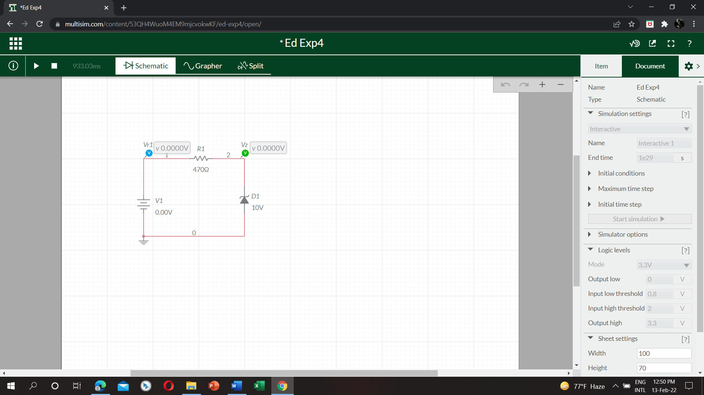

Table1:

|  |  |  |  |
| --- | --- | --- | --- |
| V | Vr1 | Vz | I=(Vr1/R1) |
| 0 | 0 | 0 | 0 |
| 2 | 2 | 1.99 | 0.00425 |
| 4 | 4 | 3.99 | 0.015 |
| 6 | 6 | 5.99 | 0.022 |
| 8 | 8 | 7.99 | 0.029 |
| 10 | 10 | 9.88 | 0.037 |

Circuit2:

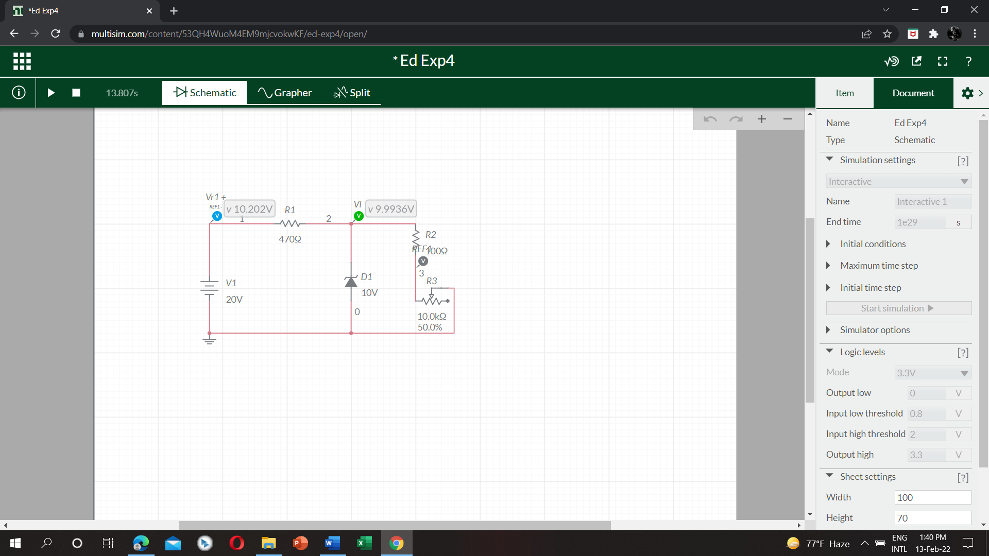

Table2:

|  |  |  |  |  |
| --- | --- | --- | --- | --- |
| Vr | 100 | 300 | 500 | 700 |
| VL | 19.916 | 19.715 | 19.585 | 19.422 |
| IL= (Vr/R) | 0.212 | 0.368 | 1.064 | 1.489 |

Circuit3:

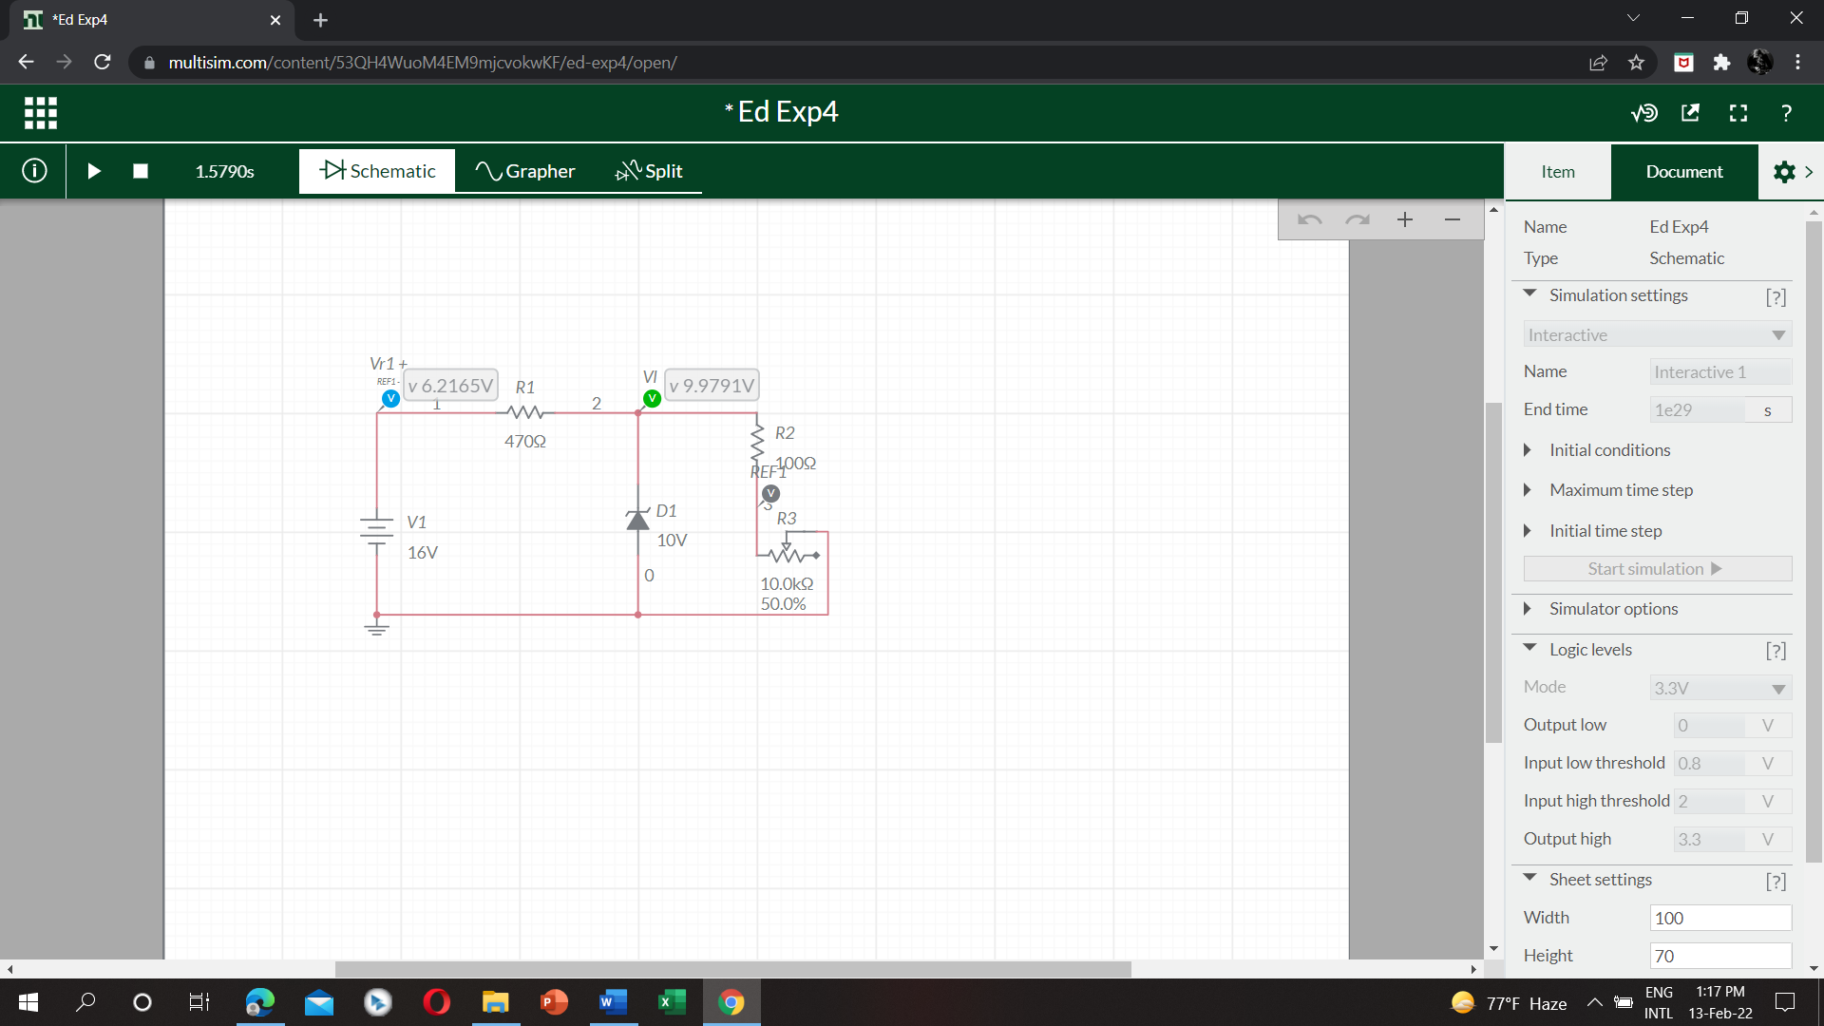

Table3:

|  |  |  |  |  |
| --- | --- | --- | --- | --- |
| V | 16 | 12 | 9 | 6 |
| Vr | 6.216 | 2.253 | 921.35*10^-3 | 614.24*10^-3 |
| Vl | 9.979 | 9.942 | 8.2402 | 5.493 |